1. Lab 8 - Troubleshooting the Network
2. Topology

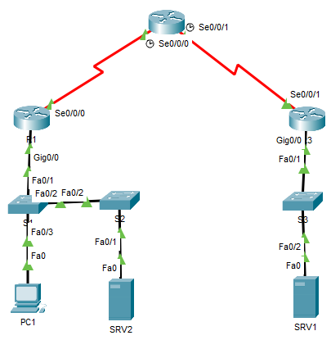

**R3**

**R1**

**R2**

1. Addressing Table

|  |  |  |  |  |
| --- | --- | --- | --- | --- |
| Device | Interface | IP Address | Subnet Mask | Default Gateway |
| R1 | G0/0 | 10.1.10.1 | 255.255.255.0 | N/A |
| S0/0/0 | 192.168.1.1 | 255.255.255.252 | N/A |
| R2 | S0/0/0 | 192.168.1.2 | 255.255.255.252 | N/A |
| S0/0/1 | 192.168.1.5 | 255.255.255.252 | N/A |
| R3 | G0/0 | 172.16.1.1 | 255.255.255.0 | N/A |
| S0/0/1 | 192.168.1.6 | 255.255.255.252 | N/A |
| PC1 | NIC | 10.1.10.10 | 255.255.255.0 | 10.1.10.1 |
| SRV2 | NIC | 10.1.10.100 | 255.255.255.0 | 10.1.10.1 |
| SRV1 | NIC | 172.16.1.100 | 255.255.255.0 | 172.16.1.1 |

1. Instructions
2. IMPORTANT: Please open Lecture 9 - Network Troubleshooting (available on the WAN Brightspace page). This has some very useful slides beginning on slide 17 which specifically walks through some helpful tips on this lab.

In this lab you must use your troubleshooting skills to review the current network and then identify, isolate and resolve any issues. **Once complete, every device should be able to ping every other device.** PC1 should also be able to enter **http://www.wantech.com** into its web browser **and successfully see the web page stored on SRV1.**

**As you identify issues, make a note of each e.g. on paper so that you can use these notes when you take the Brightspace quiz.**

1. Current set up

* All routers are configured with **static routes**
* The ports on S1 & S2 which are connected to hosts are using VLAN 5.
* There is an ACL configured on R3 G0/0 to permit traffic from the 10.1.10.0 / 24 network
* SRV2 is the DNS server for PC1
* SRV1 is a web server which should accept HTTP and HTTPS page requests

1. Hints

* Use troubleshooting commands ping and traceroute to help verify a problem
* Check all IP addresses, subnet masks, DNS servers & default gateways have been correctly configured as per the addressing table and that all interfaces have been enabled
* Verify VLANs are correctly configured on switches. The IT administrator has let you know that there is no need to configure the link between S1 & S2 as a trunk port, however you do need to configure the port between S1 & S2 as an access VLAN 5 (as currently they are experiencing errors).
* One static route is known to have a wrong exit interface, remove this and ensure to use the correct exit interface in your static route statement.
* Check ACLs have been correctly configured and applied (Tip: Ensure the ACL is applied in the right direction (e.g. remember ACLs can be applied in either an inbound direction (keyword **in**) or an outbound direction (keyword **out**).
* Where ping connectivity is possible to a server, verify the appropriate application layer service (e.g. HTTP, DNS etc.) is correctly activated (i.e. turned on) on the server

**Refer to the steps in lecture 9 for troubleshooting end-to-end connectivity**

**NOTE: For this lab, it is recommended to only attempt Brightspace quiz and submit answers after you are finished attempting to complete the troubleshooting.**

**Once you are finished attempting the lab, go to the “Lab 8 - Troubleshooting the Network – QUESTIONS (2025)” quiz on the Brightspace page and enter your answers for questions 1-7 below.**

**QUESTION 1** What, if any, were the problems with the network relating to **IP addresses** that needed to be troubleshooted?

**QUESTION 2** What, if any, were the problems relating to **interface** **statuses**?

**QUESTION 3** What, if any, were the problems relating to **VLANs**?

**QUESTION 4** What, if any, were the problems relating to how **ACL** rules were configured?

**QUESTION 5** What, if any, were the problems relating to how **ACLs** have been **applied** to **interfaces**?

**QUESTION 6** What, if any, were the problems relating to the **applications** running on the **servers**?

**QUESTION 7** As outlined above, once the network has been fully troubleshooted, PC1 should be able to successfully navigate to www.wantech.com to view the webpage on SRV1. If you are able to do so, what is the message that is displayed on the webpage?

**If you have correctly configured all parts of the lab your activity score should now be showing as 100%. If so, click on “check results” in the activity window. Enter the code into the appropriate question box (Q8) of the Brightspace quiz.**

**You have completed the lab – please submit the Brightspace quiz.**